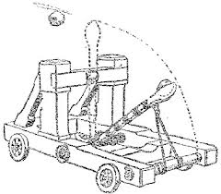
Introduction to Projectile Motion

Learning Goals
- Understand the independent x and y components of velocity
- Understand how the x and y velocities combine to form
the resultant velocity

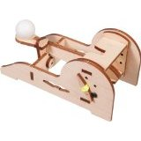
Projectile Motion in the Physical World – Build Your Own Catapult!
- Using the laser-cut wooden pieces, assemble your catapult
according to the accompanying instructions
- Lay out the measuring tape and have one person hold a yard stick
vertically about 2 feet from the catapult
- As one person gets ready to release the catapult, the other 2 partners should
stand ready to start and stop the stopwatch during the ball’s flight, mark the
tallest height the ball reached, and the distance from the catapult that the ball landed
- Fill in the table below
- Repeat steps 2 through 4 for different tension settings

Tension Setting | Flight Time | Horizontal Distance | Vertical Distance

Getting Started in Algodoo
- Open Algodoo and load the file called “Intro to Projectile Motion”
- Follow the instructions outlined on the file
- Fill out the form below

Time | Horizontal Distance | Vertical Distance | Horizontal Velocity | Vertical Velocity | Actual Velocity

How did you use the horizontal velocity and vertical velocity to find the actual velocity? Show your steps.

Why do you think you used the Pythagorean theorem to find this number?

Describe what horizontal and vertical velocities are.

Back to the Physical World
Now that you’ve learned the theory behind projectile motion, go back to your catapult and play around with settings:
- Find the settings that produce the highest vertical distance. What are the horizontal and vertical velocities? What is the actual velocity? What do you notice about these numbers?
- Do the above by find the longest horizontal distance and answer the questions as they apply to that setting

